SENIORS:
Want a Chance to Win Up to
$7,500 for College?

Virginia Bankers Association
Bank Day Scholarship program

Do you need $7,500 to help pay for your college tuition? Have you always wanted to learn more about the banking industry? If so, consider participating in the Virginia Bankers Association (VBA) Bank Day Scholarship Program in March 2026! Citizens Bank and Trust Company will host selected students on March 17th at their Main Office in Blackstone, Virginia for a day of interactive fun and learning! Selected students must attend Bank Day at CB&T and write an essay about what you learned to be eligible to win BIG scholarships!

What’s Bank Day?
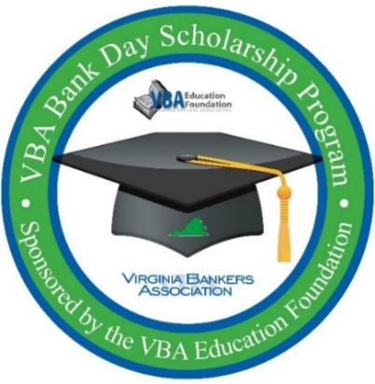
A one-of-a-kind experience where you:
- Visit a local bank and see how it works
- Learn smart money tips for your future
- Explore banking careers
- Discover how banks support your community

Scholarships Available:
- 6 Honorable Mentions: $1,000 each
- 6 Regional Winners: $2,500 each
- Statewide Runner-Up: $5,000 total
- Statewide Winner: $7,500 total
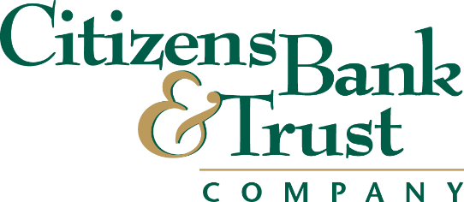
Who Can Participate?
- Virginia high school seniors
- GPA of 3.0 or higher
- Must register by February 27

Important Dates:
- February 27: Registration deadline
- March 2–27: Bank Day experience + resource site access
- March 17: Citizens Bank and Trust Bank Day (Main Office)
- March 27: Essay due
- Late April/Early May: Winners announced

Interested students must register by February 27 online here: https://forms.office.com/r/R6U1nbwcv6
Questions? Contact Monica McDearmon, VBA Vice President, Communications & Financial Education, at mmcdearmon@vabankers.org or Jay Carr, CB&T Marketing Coordinator, at Jay.Carr@cbtva.com.

